Query 1:

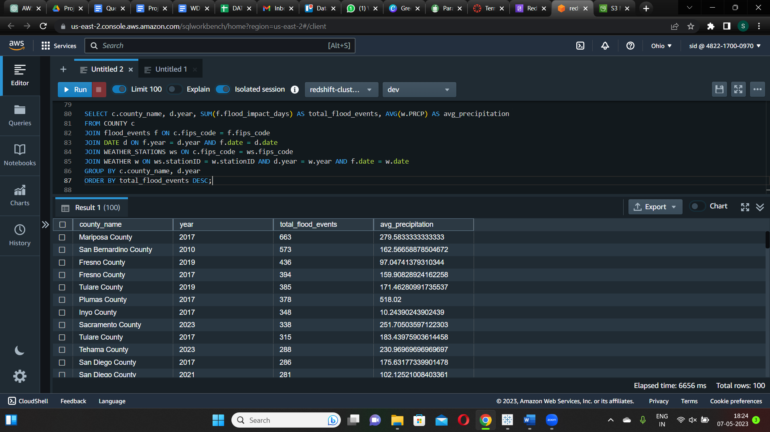

This SQL query retrieves the total number of flood impact days and average precipitation for each county and year combination by joining the COUNTY, FLOOD_EVENT, DATE, WEATHER_STATION, and WEATHER tables. The results are organized by county name and year, and then ordered descendingly by total flood events. This query can provide information about the relationship between flood events and precipitation patterns in various counties over time. The result shows the total number of flood events in counties in a descending order with the average precipitation they received in the mentioned year.

Query 2:

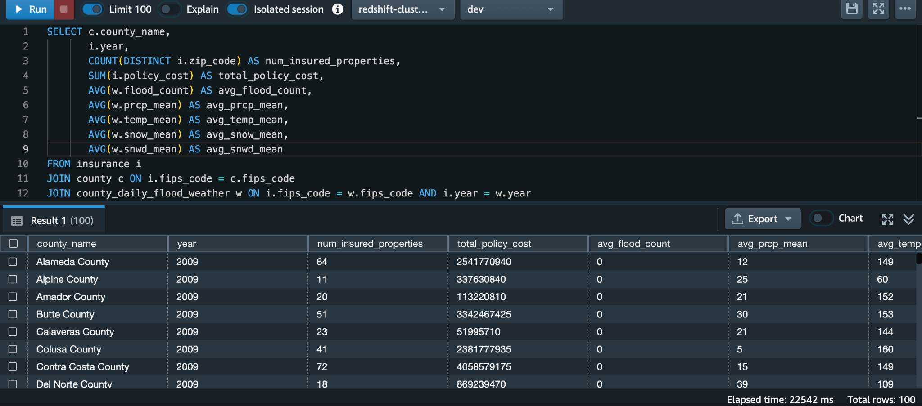

The SQL query joins three tables to calculate the total number of insurance claims, total policy cost, and average policy cost per claim for each county in California for each year, as well as the total number of flood events and average flood count per day. The findings show a positive relationship between flood events and insurance claims, with more flood events leading to more insurance claims. This emphasizes the importance of mitigating the effects of flooding on communities and reducing the financial burden on individuals and insurers.

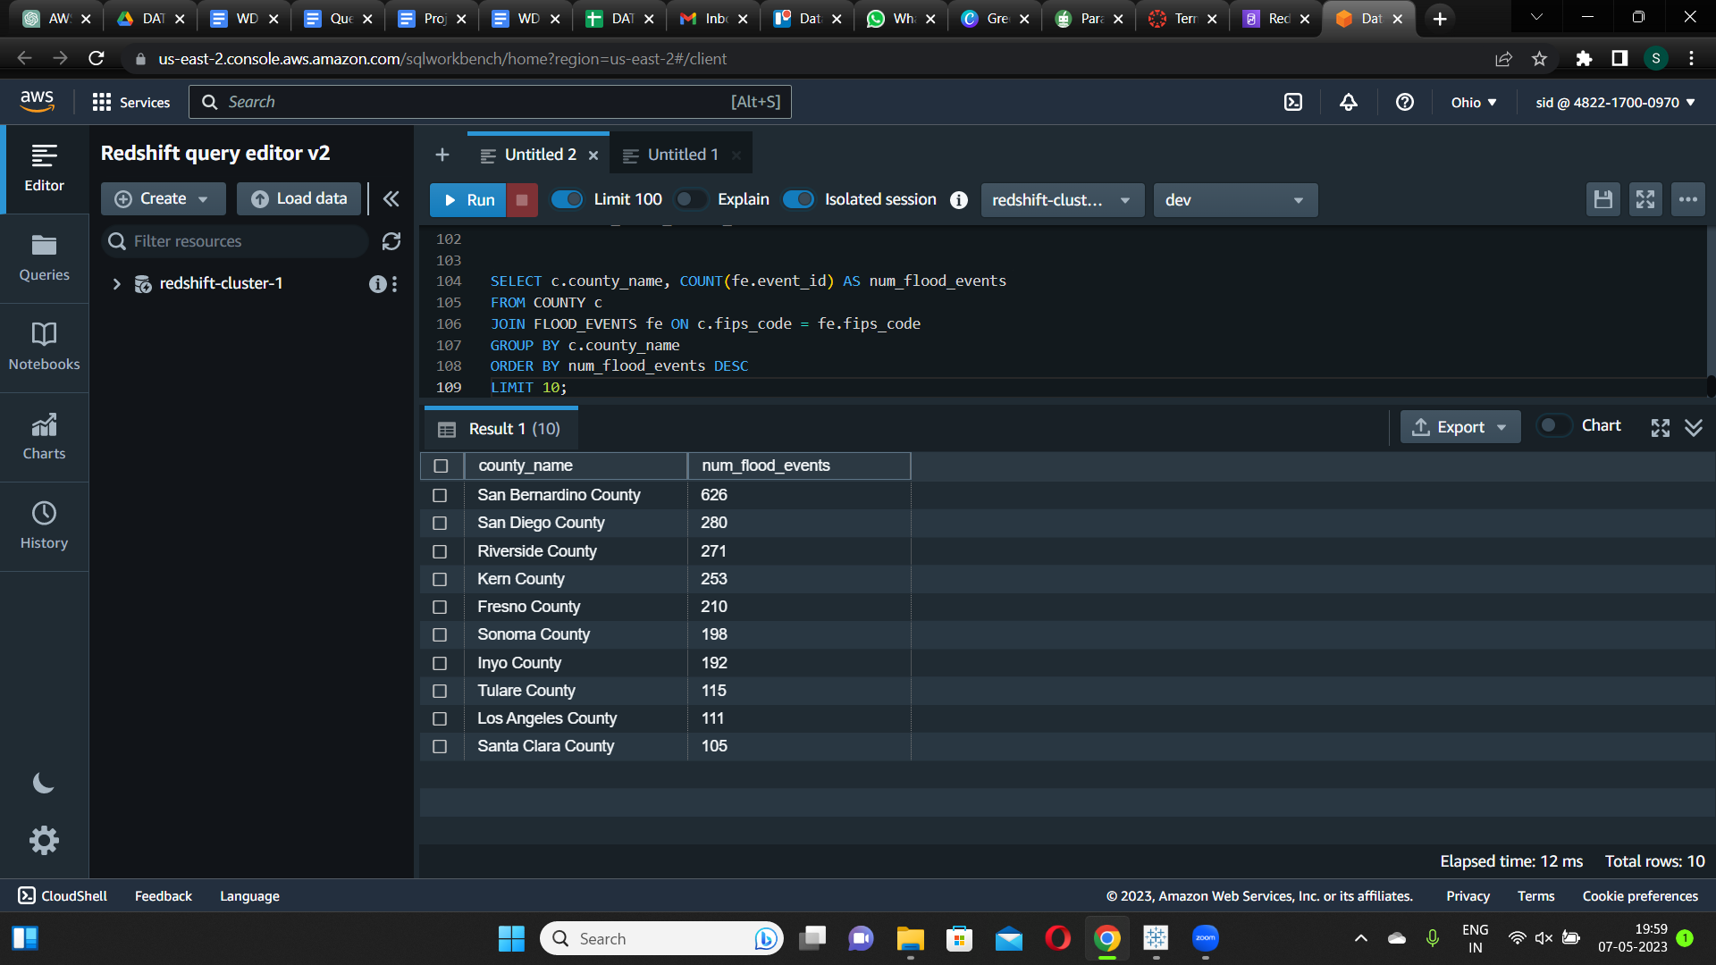

The query returns the top 10 counties in California with the highest number of recorded flood events, along with the corresponding number of flood events in descending order. The result shows that San Bernardino County has the highest number of recorded flood events with 626 events, followed by San Diego County with 280 events and Riverside County with 271 events. This information could be useful for identifying areas where flood mitigation efforts may be most necessary.

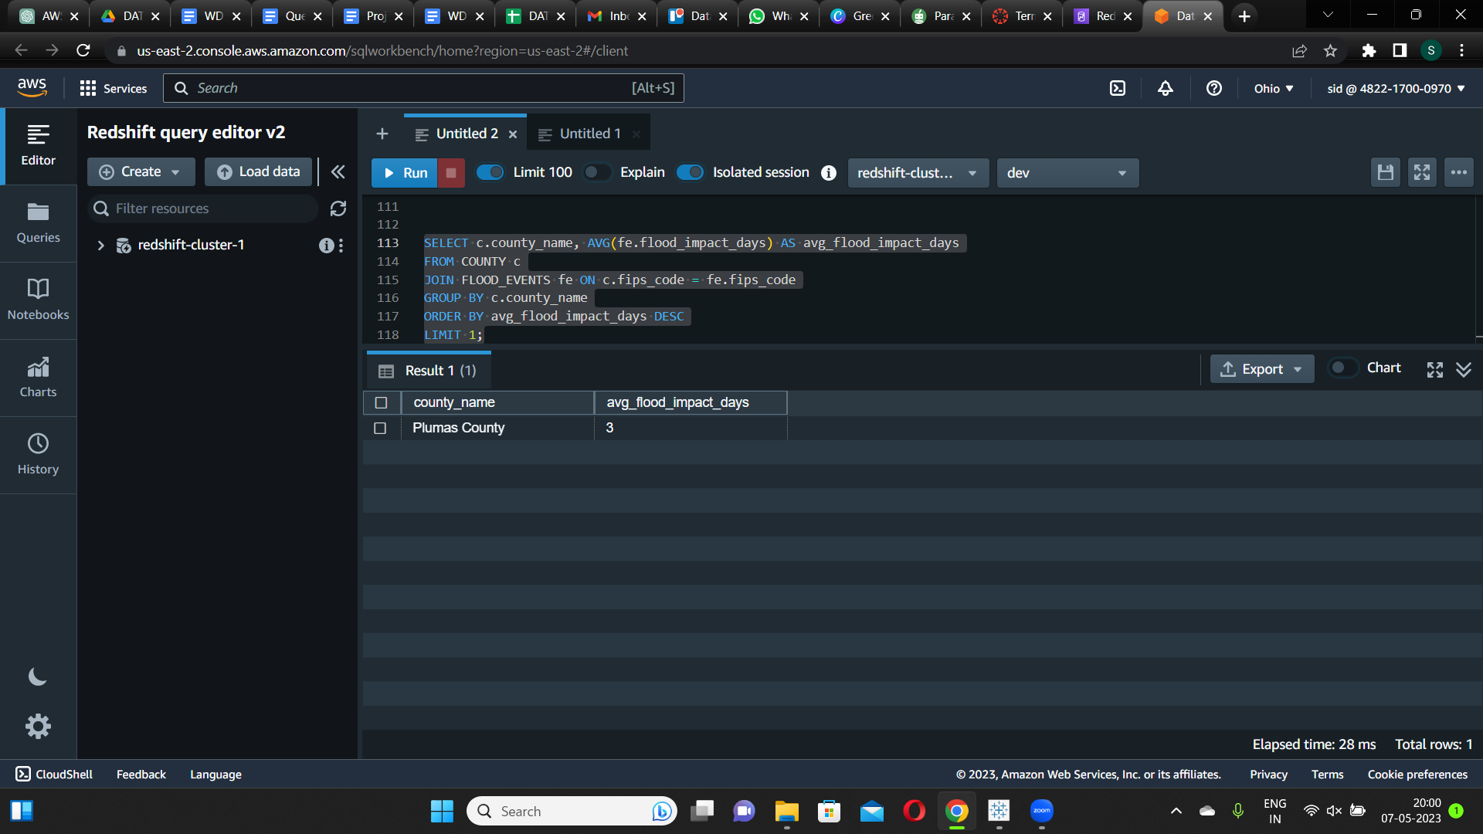

This query returns the county in California with the highest average annual flood impact days. The result shows that Plumas County has the highest average annual flood impact days at 3 days. This information could be useful for identifying areas where flood insurance may be more necessary or where flood prevention measures may be needed.

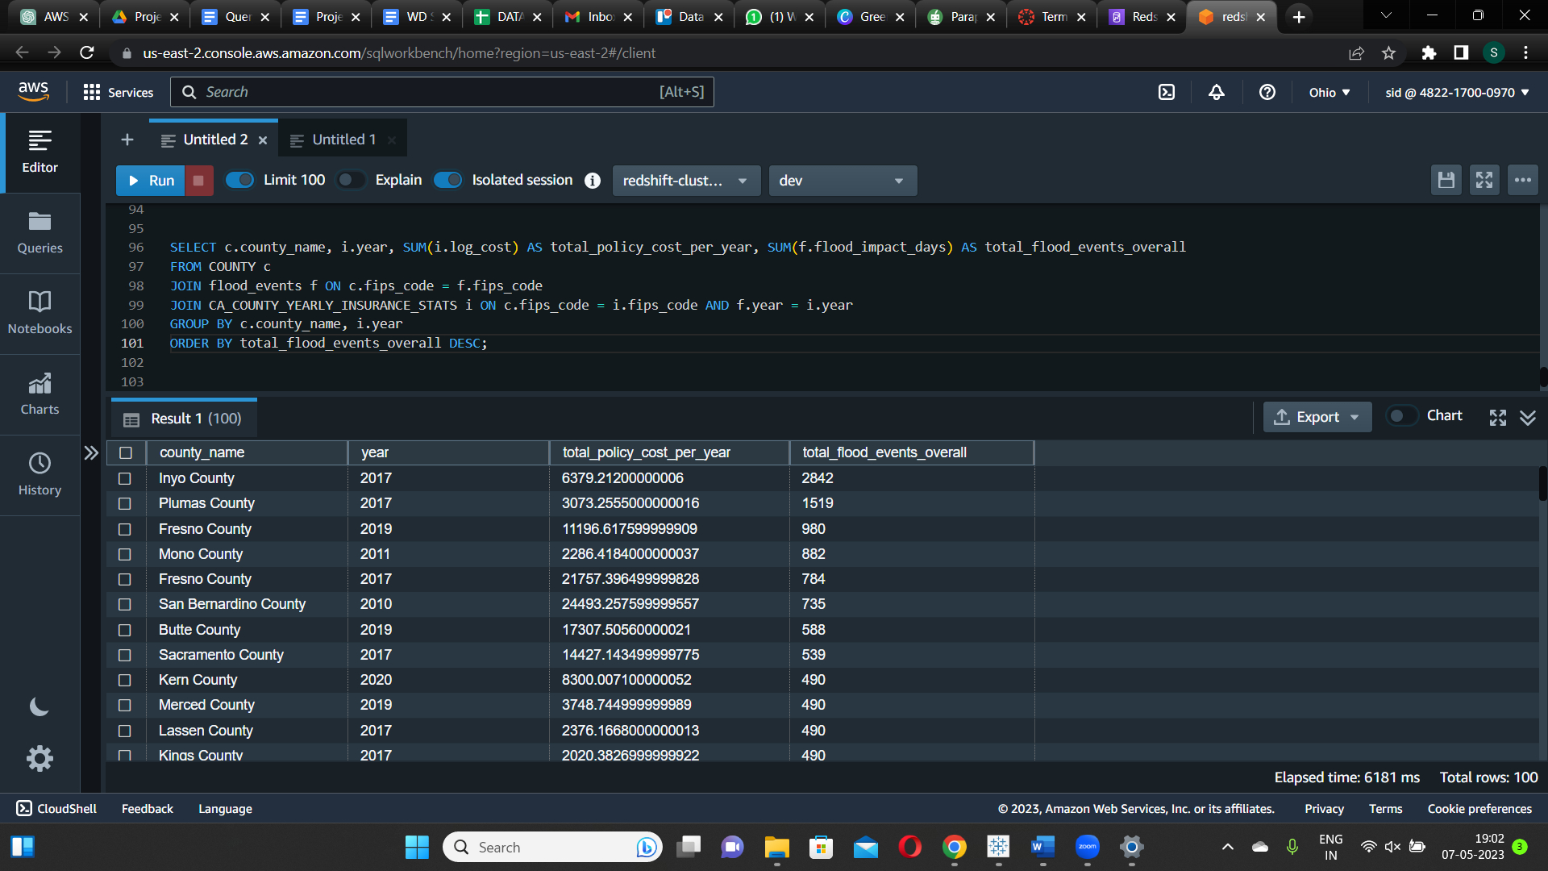

The county, flood events, and California county insurance stats tables are joined in this SQL query to calculate the total number of flood events and total policy cost for each county in California for each year. The result shows the total number of flood over all the years from 2005-2023 and the total policy cost per year for a particular county.